Feedback on ‘Solo Mode – Pilot 1’

PAGE 1
Game structure
- Definition of round and relationship with market stage
- In this pilot, I understand round 1 position is DAM position and adjustments made in subsequent rounds simulate the IDM – Is it possible to limit the scenario to a single round (only DAM)?
- Is it possible to limit the number of hours forecasted to a single hour in Day +1?
- Once the scenario starts, does the trainer has the flexibility to extend the time limit of the round without restarting/recreating the scenario?
Objectives:
- Could we adapt the objectives depending on the campaign/scenario?
- From the perspective of the upcoming Power Futures Lab course, the current list of objectives seems to fit for level 3 (Trading under uncertainty). Before reaching this level, we would like to introduce the mechanics of power markets before introducing strategic bidding and uncertainties.
Challenges
- Is 4,000,000 ZAR break-even revenue? Would it be the same for all players and roles?
- Alternative targets:
  - Relative increase in profit compared to the reference result (first round in the DAM)
  - Percentage of imbalance cost/volume
- It would be consistent if we could link the challenges to the specific objectives
START SCENARIO
PAGE 2 - First round (DAM)
Session info
- Scenario Briefing
  - The scenario description can focus on the
    - Type of market products activated (DA, ID, BAL?)
    - Description of the day (weather, demand forecast, share of wind and solar …)
    - Overview of participating generators (type of technology, capacities…)
  - Objectives
    - Shouldn’t this be aligned with the objectives listed on the first page?
  - Session details
    - Why is the forecast horizon set for 48 hours, beyond the horizon of the market?
  - Markets
    - Price range of 0-5000ZAR/MWh is indicated. The price cap of 5000 ZAR/MWh to be aligned with the SAWEM (I believe it is around 1100 ZAR/MWh)
  - Grid configuration
    - Please also add information regarding the transfer limit between zones
    - I would also add information regarding the split of the demand and total generation capacity per zone
    - Including transmission losses could provide interesting learning insight. However, I would not include it as part of the first couple of levels. It should also be clear how loss is allocated to the players and reflected in the results.
  - Player type
    - Additional information regarding the portfolio of the player would be helpful. These include:
      - The cost function of the technology (mainly the variable/marginal cost – either constant or depending on level of production blocks)
      - The zone the asset belongs to
      - (optional) the carbon intensity of the technology as this might be relevant in some of the topics discussed in the classroom
  - Challenges
    - See comments on the first page
  - Events
    - It would be good to add more details on this
- Market structure
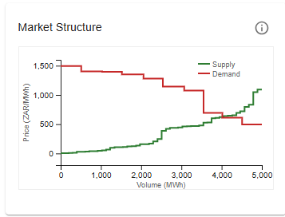
  - Is the figure static or it changes depending on the bid of the generator?
  - The player is bidding for 6 hours in this round, but I understand this merit order and offer curve only shows the state of a single hour, correct?
  - Should this be linked to the load level (base, mid, peak)?
- My Devices
  - What does the cost 600 ZAR/MWh refer to?
- Generator
  - Regarding the description “Set three different price levels and quantity curves (in MW). Lower prices dispatch first. All dispatched energy receives the System Marginal Price (SMP). Enter power per hour - e.g., 600 MW for 6 hours means 600 in each hour.”
    - Please consider revising the description -
      - use terminologies such as ‘bids’ referring to price-quantity combination,
      - instead of ‘lower prices dispatch first’ -> ‘bids are cleared from the lowest to the highest bid price needed to supply the demand’
      - instead of ‘dispatched energy receives’ -> ‘all cleared bid volume receives the SMP…’
      - by ‘enter power ..’ do you mean hourly demand? Is it the system demand or part of the system demand the generator forecasts to cover? Does this refer to the bid volume of the generator? If so, please be specific
  - I am wondering what the added value of the player (the coal generator in this case) adapting the system demand for the base, mid and peak hours of the days.
  - I would suggest focusing on tomorrow, bids in the DAM are submitted for every hour of tomorrow. Might seem interesting to link with the situation of the market that has been cleared one day ago but has less added value for this simulation game. Everything in h1 – h24 has been already covered by the DAM in Day -1, if you are making adjustments to these, it would be in the IDM.

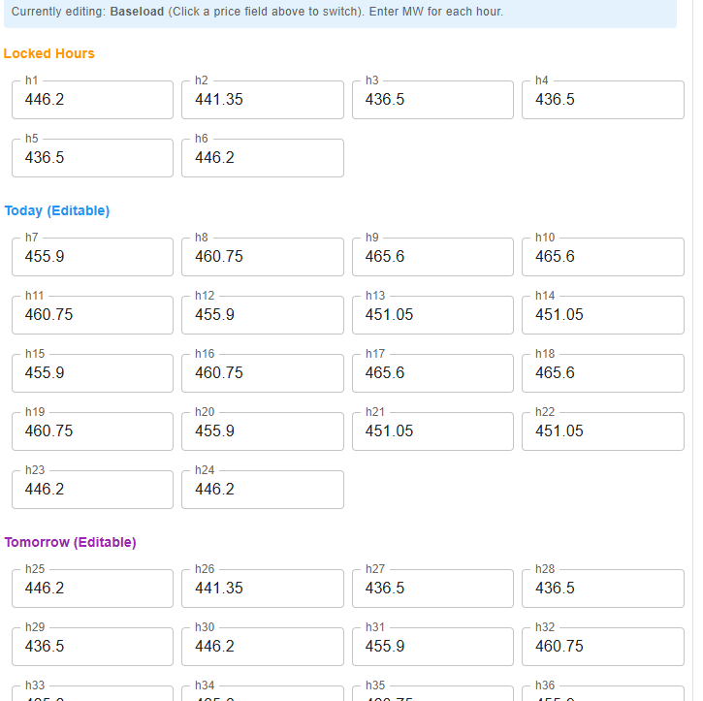
  - It is assumed that there are three prices that could be adapted when preparing the bid for the round (one price per 6 hours). In reality, a generator would have multiple bid (price x generation) combinations for each hour. The reasoning is not fully clear to me, to be discussed.
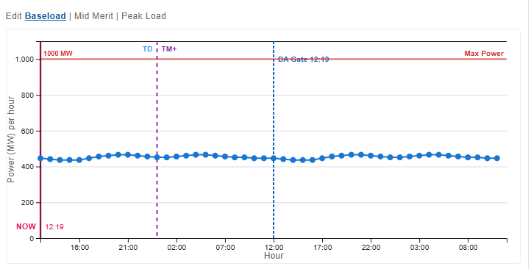
  - The representation of this figure might be misleading since in the DAM we are bidding for the hours in Day+1
  - Gate closure set to 12h, please align with the SAWEM timeline
  - It is great that this figure is dynamic, and one can easily adapt bids. However, I found it not very intuitive. I would like to discuss ways to make it simple and intuitive
PAGE 3 - Round 1 results
Your performance
  - What does ‘curtailment’ refer to for a coal power plant?
  - How is the variable cost (ZAR 2,114,600) calculated? As a product of the total bid volume cleared and 600 ZAR/MWh? If so, why is there a difference with what is displayed?
Lot breakdown
  - It is a bit strange to see a single MCP for the 24hours. In reality, it could change every hour
Hourly breakdown
  - Planned – bid volume? (you referred as ‘your offered energy’)
  - Dispatched – cleared volume
  - Looking at the results, it seems to me the bid the player submitted was not necessarily his price expected for different level of generation (‘I am willing to supply up to XX MW for a price of Y/MWh’) but rather the demand he expects to supply and the price at which he is willing to sell it (‘I expect that I will supply XX MW and I am willing to sell it at Y/MWh’).
PAGE 4 - ID?
- The volume for the first 12 hours is locked which is not fully aligned with the concept of IDM in which the generator has the opportunity to change its bids for every hour of Day +1 until an hour before delivery
- 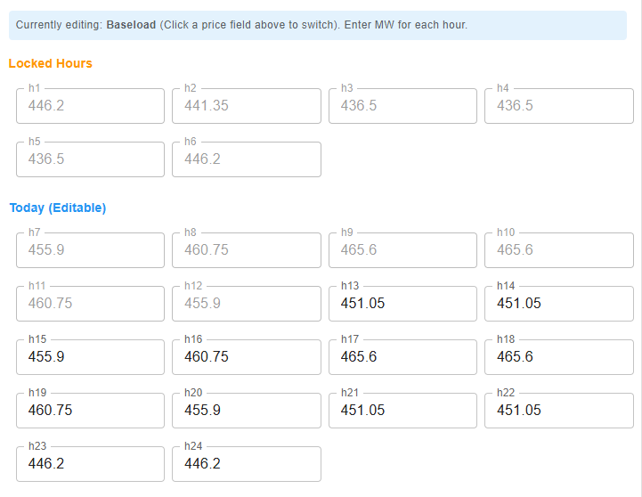

Additional feedback gathered from Elaine and Wikus
- game is not intuitive
- a “beginner’s mode” that guides new player through the game could be helpful
- Pop-ups that explain functions would be useful
- The multiplayer mode is needed
- ESMG Handbook is still faulty and includes ai hallucinations
- NTCSA, PFL and GIZ need to agree on a final imprint and description of the game
- The performance outputs are not intuitively clear: does my profit include imbalance cost and variable cost? What is variable costs? And how does curtailment impact my profit? It’s not clear how these numbers relate to each other. I can go back and look for them, but I think it should be possible to present them more intuitively?
- The revenue target of 4000000; is that arbitrary? Where does it come from? Not a criticism, just curiosity. This seems to be the basis for the “challenge met/score out of 10).
- At the moment, I can only adjust my pricing, as a generator. Will I also be able to adjust my offer (MWh)? From the instructions, it seems like I should be able to adjust offers/demand (volumes).
- The player handbook is definitely not intuitive. We want this to be playable by people in e.g. local government, that don’t have this level of experience. I think we need something like a starting guide (basic, well written and clear) that explains the game. And we probably need one for each mode/scenario. The current “player guide” reads more like a admin guide.
- The instructions for the pilot mode are written as if I am playing as a load, but then in reality I am playing as a (coal) generator. Needs to be fixed.
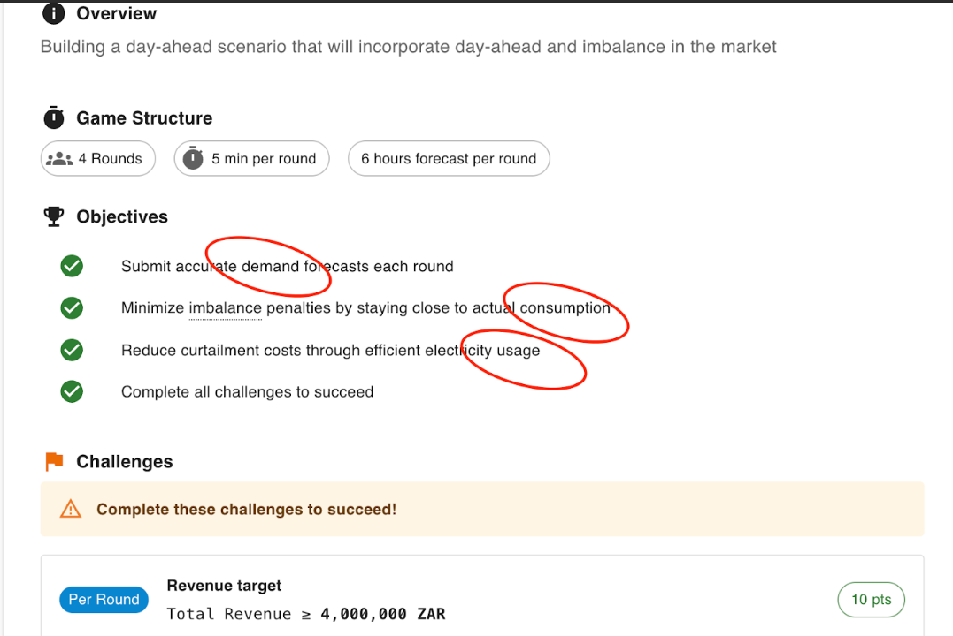
- Not clear to me what this figure (below) refers to. Seems like I can adjust it, but not sure what it is (though I think it might be volumes offered?). it would help if this was clearer. And of course, we might need to have ramp rate limits etc. incorporated? Or am I misunderstanding how this works. Also, the stacked lot overview adjusts based on this, which I guess makes sense. But this is only for my generator - not the entire market, right? Again, not quite clear.
- 